**WDEC Reloaded – User Manual**

Agnes Kim, Ph.D.

[axk55@psu.edu](mailto:axk55@psu.edu)

Faculty Member

Penn State Worthington Scranton

**1. Message from the author**

I hope the present documentation helps you get started using the code. While this documentation is minimal, I added a section near the end to encourage you to look at the source code and attempt to tell you how to use the source code to figure out what is what. It can also be useful if you are looking to make your own modifications to the code. I welcome email enquiries and will do my best to assist. I am first and foremost an Astronomer and not a developer so please pardon my coding.

I tried to structure the document to address the most pressing questions first. So I begin with a section on what you can do with this code. The next section looks boring (history), but it is important to read, as it explains some of the arcane vocabulary and structure you may encounter while using the code. Then I dig into the essentials: what the files are, how to compile the code, how to run it, what the output is. The next section gives an overview of the source code, followed by a section on the limitations. The last section is a troubleshooting section. It has figures. If you get weird output, see if your output matches one of the figures. Under each figure, I tell how to fix the issue shown.

Before you use the code to do science, please read the section on limitations. If the code crashes on you (which I am sure it will upon first use) read the limitations. Your probably put oxygen where it does not belong.

Finally, if you want more details on what the code does and how (in particular, how chemical profiles are calculated, but also other things), see the software paper Bischoff-Kim et al. 2017.

Enjoy.

**2. Use of the code**

WDEC stands for White Dwarf Evolution Code. Unlike what the name suggests, this is not a stellar evolution code. The advantage of the WDEC over a stellar evolution code is that it runs MUCH faster, and is less of an art to use. If you are looking to construct a quick white dwarf and get its periods of pulsation, this is a good code to use. A computer savvy undergraduate student can learn how to use this code and process its output over the course of a semester.

The code does have its limitations, which I defer to the end of this document. That's not because it's not important, but because I think the reader's first interest may be in finding out how to compile and run the code (but please, DO read that last section).

To run the code, you will have to provide your own interior chemical profiles. You can take one that came out of your favorite stellar evolution code, or any from the literature, or whatever crosses your mind (though again, check the limitations). You can't put gold in these white dwarfs. The interior chemical profiles are not evolved by the code (no time dependent diffusion of elements). What you put in is what you get out at the end. All other quantities are calculated by the code in order to make a model that is a solution to the proper stellar interior equations.

You also provide what temperature you want your white dwarf model to have. The code will calculate a model with that temperature. Then you have the option of having the code calculating pulsation properties of the model you produced.

This code can run on any modern laptop (and even older). It will take about 12 seconds to run.

**3. A brief history of the code**

The original lines of code date back to the early 1970's. It was written in Fortran. The first paper written about the code (and only one specifically about the code until 2017) was Lamb & Van Horn 1975, Astrophysical Journal, 200, 306.

Don Winget inherited the code, when he was a very young graduate student at the University of Rochester. The present author had the opportunity to go back to 40 year old research notebooks that helped her make sense of what some of the quantities in the code are (just a few, the quest continues). He brought the code with him to the University of Texas at Austin, where generations of his students made additions and modifications. Some are documented in the source code.

Significant modifications code wise included a repackaging of the different pieces of the code by Travis Metcalfe in the 1990's for use on super computers. The original code had 3 parts to it: the evolution code which made a white dwarf model. Then there was a “prep” code, which added shells to the model to increase its resolution and computed some quantities needed in solving the equations of non-radial oscillations. Finally, a pulsation code would take output from the prep code and compute pulsation periods and other pulsational properties. You might see these three elements mentioned as you explore the code, so this part of history is important to know.

Two decades later, the present author rewrote the code in Fortran 90 and modularized it, in order to be able to incorporate into the code state of the art opacities and equations of state from MESA (Modules for Experiments in Stellar Astrophysics). Mike Montgomery wrote the wrapper routines that allows WDEC to interface with the MESA modules.

This is the version of the code you have here. The use of MESA code means that the code is more challenging to install and also runs less fast. But it is a good sacrifice to make for state of the art physics. The use of MESA modules also means that there is more flexibility in terms of what chemical elements can be included (though there are still limitations!).

I should note that you do have the option of running the code with older physics, in which case there is no need to install MESA and the code runs faster. For something quick and dirty, that might be a good option. Be aware that in that case, there are more restriction on the chemical profiles.

Because it is fast, the code has been used to calculate extensive grids of models to do period fitting. This is important to know, as it explains the slightly clunky way to run it, which involves first generating a file with input parameters then using that file as input. For a single model, that's a clunky method. But if you want to run a series of models, the input parameter file can be used to run batch jobs.

**4. Packing list**

The files fall into 3 categories: source files, input files, supporting files.

**Source files**

Those are the fortran routines that make up the meat of the code and a Makefile for compiling.

block_data.f90

calcp_mainroutine.f90

chemprofiles_subroutines.da.f90

chemprofiles_subroutines.f90

chemprofiles_subroutines.heliumcore.f90

commonblocks.f90

eos_wd.f90

eprep_subroutines.f90

evol_mainroutine.f90

evol_subroutines.f90

getpar_grid.f90

istat_subroutines.f90

nuax_subroutines.f90

ocon_functions.f90

phase_functions.f90

pulse_mainroutine.f90

pulse_subroutines.f90

utils_subroutines.f90

wd_eos_mod.f90

wd_opalz_mod.f90

wd_test.f90

Makefile

**Input files**

These are the files you will be editing to get the code to produce the white dwarf(s) you want.

controlparams

gridparameters

inputprof

**Supporting files**

These are files the code reads from while making models.

Directory called masses and the starter model files it contains.

Equation of state and opacity tables:

AUXIN5

EEOSC

EEOSH

EEOSHE

IEOSC

IEOSO

SQOPAC

**5. Compiling the code**

A template Makefile is included with the source files. It can be used as is if you are on a Linux system and have either the gfortran or the ifort compilers (uncomment the proper lines). If you are running another OS and/or a different Fortran compiler, you will need to edit the flags as required, or write your own compiling script.

There is one compiling script for making different codes. Details below.

**The quick and dirty old version (does not require MESA)**

You can try compiling this one first for practice. In that case, you want to comment out the two MESA_DIR lines in Makefile. To compile, type

$ make makeda

This version of the code uses the opacitie and equations of state tables listed above. Everything it needs to run is right in the code directory. It runs faster than the state of the art version.

**State of the art version**

Before you can compile and run the state of the art version of the code, you must first download and install MESA. This is a non-trivial process and MESA is no small code, but there is excellent online and community support as MESA, unlike WDEC, was written by a team of professional developers (and astronomers).

To get MESA, go to <http://mesa.sourceforge.net/index.html>. VERY IMPORTANT: you need to download a specific, older version of MESA, version r8118. Libraries move around and variables get renamed from version to version, so WDEC will not be able to interface with any other version of MESA. Of course, you can rewrite some of the source code to make WDEC interface with whatever version of MESA you want to run. But for the average user, the best option is to get MESA version r8118 and install that.

Once you have MESA installed, edit Makefile to point to the proper directory then compile the code you want to use. There are two different ones.

**C/O core white dwarf**

$ make makeda_new_da

**Helium core white dwarf**

$ make makeda_new_he

**6. Running the code**

Aside from the equation of state tables and the starter models (located in the directory masses/), there are 3 input files that you will be editing: controparams, inputprof, and gridparameters.

**Controlparams – Tell the code what you want it to do for you**

Controlparams contains a series of questions to which you need to specify answers. The questions are in plain English, but some might be a little cryptic. See section 3 for some background. A brief explanation of each question follows.

The first two questions (about MESA equations of state and opacities) refer to using the old version of the code or the state of the art version. If you did not install MESA, you can still run the code if you answer N to these two questions. The code will use the equations of state tables and opacities that are right in the current directory.

“How do you want to treat convection?” The answer to that question is either 1, 2, or 3. Explanations given right in the controlparams files. For further details, see Bischoff-Kim et al. 2017.

“Do you want screen output from the evolution code?” Your anwer is likely “N”, unless you want to see stuff scrolling on your screen during the execution. It might be useful for debugging purposes, but the screen output might be a little cryptic. It is the historical output.

“Do you want tape file output from the evolution code?” Your anwer is most likely “N”. First of all, the output no longer gets written out to tapes, but to files named e.g. tape28. In the original form of the code, these files were read back in by the prep code (see section 3). The format of the files is not meant to be easy to read by humans, or to be easy to plot. Again, it might be useful for debugging purposes.

“Do you want file output from the prep code to make plots?” Your answer to that might be “Y”, if you want to build a single white dwarf model and learn about its interior structure. The file output is meant for easy reading by humans and/or use in plotting routines. It may take some work to figure out what is what, however, as most files do not have headers. In section 8, I give some guidance on how to do that. Section 7 gives a general description of the output files and is a useful overview.

The next two questions are self-explanatory. It may seem silly to ask about file output seperately from calculating pulsations. If we calculate pulsations, we obviously want to write out pulsation output. The pulsation output gets written at different stages in the code, so this is not an innocent question. Essentially, there is a summary of periods that gets writen out no matter what, and then more detailed output that one may activate. More on file output in section 7.

The last question refers to output that allows to plot weight functions that show where the modes are trapped (Montgomery et al. 2003). It is not that much trouble to incorporate as I have source code that does that, I just never got to it. If you are interested in incorporating this, or want to run kernels output separately, please contact me.

**Inputprof – Provide a desired shape for the chemical profiles in the model**

The file inputprof contains some explanations. In a nutshell, you are asked to provide the oxygen abundance profile. It is important to specify how many points you are providing to specify the oxygen profile, as this programmer was too lazy to automate that. If it drives you crazy, you can go into the source code and make that improvement (please consider sharing the improved code).

Then there is a parameter that specifies how closely you want the actual profile to follow what you specified. If you are giving only a few points and want the code to build a smooth curve off of that, go with something closer to 10. If you are feeding it a profile from a stellar evolution code that you want to use as is, then use 500. This will cause the code to essentially use the profile you gave it and not smooth anything.

The last two parameters define buffer zones around locations of transition zones in the chemical profiles. The first one is buffer_inner (in Mr units) and the second is buffer_outer (in -log(1-Mr/M*) units). These parameters may have to be tweaked in order for the chemical profiles to be smooth. See more details in the troublshooting section.

Gridparameters – Provide additional input parameters, for one or more models

The file gridparameters must contain at minimum one line, specifying properties of the desired model. You can add more lines if you want to run a batch of models. The single line may look like this

40000. 600. 500. 700. 800. 60. 10.0 10.0 1.0

This will make a white dwarf that has a temperature of 40,000 K, and a mass of 0.600 Msun. The last parameter sets the convective efficiency. The rest of the parameters specify chemical abundance profiles in the envelope (where there is helium and possibly hydrogen). A picture is worth a thousand words so the figure below illustrate what the chemical abundance parameters specify. The best way to familiarize yourself with what each parameter does is to run models varying one parameter at a time and see how that parameter changes the chemical profiles.

As a side note, in case you are wondering why these are specified as positive values greater than 1 (multiplying when necessary), it goes back to days when these parameters were fed into the code through shell scripting (and so no decimals allowed). This arcane convention remains because of laziness (but also because looping through whole numbers is conceptually easier when creating grids).

!!$datain(1) = 11500.!Effective temperature

!!$datain(2) = 600. !Mass

!!$datain(3) = 150 !Menv

!!$datain(4) = 200. !Mhe

!!$datain(5) = 400. !Mh

!!$datain(6) = 0.60 !Helium abundance in mixed C/He/H region

!!$datain(7) = 2.0 !Diffusion coefficient for He at the base of the envelope

!!$datain(8) = 2.0 !Diffusion coefficient for He at the base of pure He

Once you have specified the input, simply run the executable by typing

$ ./makeda_new_da

Execution should take under 30 seconds. If it is longer, it is probably hanging. Kill the process and relaunch after editing controlparams to get screen output. Also try changing the input parameters in gridparam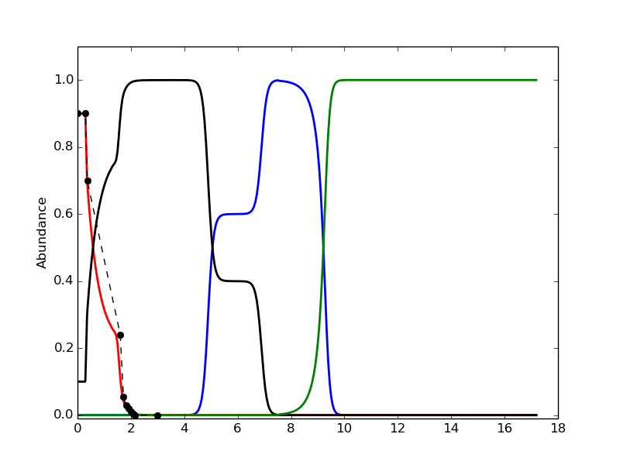eters.

**7. Description of key output files**

In this section, we limit ourselves to discussing some key output files. In the past, I and other WDEC developer have produced documentation describing at least some of the output in detail, but such documentation quickly becomes outdated and in our case was never complete to begin with. It appears that it is more useful to arm the reader with the weapons to figure out what the output is, from the code. This is also safest. This will be discussed at length in section 8.

Depending on the flags you set in controlparams, you will get anywhere between 1 and 30+ files.

**calcperiods**

If you do something silly like saying “N” to all output in controlparams, you still get the file calcperiods, but it will not list any periods. It might look like this:

40000. 600. 500. 700. 800. 60. 10.0 10.0 1.00

0.0000000000000000

100000

It spat the parameters listed in gridparameters back out, then there is 0. and then 100000. I explain the latter below, with an example where we did ask to calculate pulsation periods. The code writes out the calculated periods to calcperiods. Then calcperiods might look like this:

40000. 600. 500. 700. 800. 60. 10.0 10.0

1 129.63071929222846

1 167.30720084865592

1 197.38566565316265

1 226.92951357895177

1 253.05251098532727

1 284.69333321586623

1 316.93330428778086

…

1 1430.1725198348511

1 1461.3989465485579

1 1493.6983813392360

1 1493.6983813392360

2 102.93378501409387

2 120.27516329156133

2 139.25283753152820

2 152.22916991972829

…

2 1450.5330101765014

2 1467.6631650174181

2 1486.0908532143724

2 1486.0908532143724

0.0000000000000000

100000

Now we have a set of periods (ell=1 and ell=2) before the 0. and the 100000. The zero used to be a place where the code would output a fitness parameter comparing the list of calculated periods to a list of periods that we were trying to match. The matching subroutine and the computation of the parameter have been stripped out of the code and is today a standalone code (available on request). For purposes of interfacing with existing tools, I left a double set to zero as a place holder. The 100000 acts as a separation between successive lists of periods, when running more than one model at a time in gridparameters.

**Results.dat**

To get more information on the pulsation periods, say “Y” to output from the pulsation code and open results.dat. It has radial overtone values, kinetic energies of the modes, and more.

**Evolved**

Evolved is a key file. You obtain it if you say “Y” to “Do you want tape file output from the evolution code”. The file evolved contains key quantities that describe the model. Unfortunately, it is not in a human or plotting routine readable version, as it lists the values in blocks on a page 4 column wide. See section 8 for more on deciphering that file.

**Plotting ready files**

An easy way to extract most information from the evolved file is to say “Y” to “Do you want file output from the prep code to make plots?”. Then you get a series of files with model values organized in columns, which a plotting routine can easily grab. Most such files have “.dat” endings. Some file titles are self-explanatory, most are not. See section 8 for help on determining what is what.

**8. Some uses of peaking at the source code and some help on that**

As has been eluded to in the previous section, one big use of peaking at the source code is to figure out file output in detail. I will also discuss how to find out what at least some of the variables in the code are (always a big issue and an ongoing process), and how to recover what the paramaters set in gridparameters are and to see what some of the defaults are. I begin with a practical example of figuring out what is in a given output file.

**Determining what is in the output files for the non-Fortran savvy**

As an example, let's say you are trying to figure out what gets written out to the all important “evolved” file. First, find mentions of this file name in the source code, using grep. E.g. in the folder where the source code is, type

$ grep 'evolved' *.f90

Two outputs come up. One has an exclamation point starting it. That means it is a comment, so unlikely to be what we are looking for. The relevant output is

evol_subroutines.f90: fname = "evolved"

We open evol_subroutines.f90 and search for 'evolved' to find that given line of code. It appears that 'evolved' gets saved as a string variable called fname. So search for that. We find the line

open(50,file=fname,status='unknown')

This is useful. It tells us that Fortran opens the file named 'evolved' as unit number 50 (some loose Fortran 90 here). The line write under it says

open(50,file=fname,status='unknown')

write(50,161) modnr,ssg,p2,t2,ucent,rm,tel,bl,bnt,bax,10.**amxc

Search for other instances of 'write(50', or if that fails 'write (50' (add a space between “write” and the partenthesis). We don't find any other ones in evol_subroutines.f90. That means the rest is elsewhere. Using grep again, we find

eprep_subroutines.f90: write(50,1030) nshell, nl,nel,amhyhe,amheca, &

eprep_subroutines.f90: write(50,1020) (aa(i,n), n=1,nshell)

evol_subroutines.f90: write(50,161) modnr,ssg,p2,t2,ucent,rm, ...

pulse_mainroutine.f90: write(50,3005) mstar,model,age,llsun,rrsun,...

pulse_mainroutine.f90: write(50,3007) amhyhe,amheca,alph(1), ...

pulse_subroutines.f90: write(50,1003) gnu0,per0,tdyn

The second output seems to be the promising one, as it looks like it is writing out a lot of numbers (a 2D array with at least one dimension being the number of shells). But we are still left in the dark. What quantities does the array aa(:,:) contain? Grep!

$ grep 'aa(' *.f90

And here, we score. Lines and lines of output, but the top ones are very useful (we land on one of the better commented parts of the code).

commonblocks.f90:! aa(1,:) = radius

commonblocks.f90:! aa(2,:) = mr

commonblocks.f90:! aa(3,:) = lr

commonblocks.f90:! aa(4,:) = temperature

commonblocks.f90:! aa(5,:) = density

commonblocks.f90:! aa(6,:) = pressure

commonblocks.f90:! aa(7,:) = neutrino emission rate

commonblocks.f90:! aa(8,:) = cv

commonblocks.f90:! aa(9,:) = chr

commonblocks.f90:! aa(10,:) = cht

commonblocks.f90:! aa(11,:) = epst

commonblocks.f90:! aa(12,:) = epsr

commonblocks.f90:! aa(13,:) = kapr

commonblocks.f90:! aa(14,:) = kapt

commonblocks.f90:! aa(15,:) = del

commonblocks.f90:! aa(16,:) = delad

commonblocks.f90:! aa(17,:) = xhe

commonblocks.f90:! aa(18,:) = kap (opacity)

commonblocks.f90:! aa(19,:) = ledoux term

commonblocks.f90:! aa(20,:) = oxygen abundance

This is an illustration of using code reverse engineering to figure out what the output is, and a great segway into the modules of commonblocks.f90

**The two files that contain most of the variables**

commonblock.f90 is where the more globally used variables are defined, and that's a lot of them. The vast majority of them remain unidentified, but as I worked on the modern version of the code, I added comments, so you may find some useful information about the variables in that file.

Another file where one finds global variables is block_data.f90. That file is more oriented toward defining constant values (or as Fortran calls variables that are not to be modified in the code, “parameters”). For historical reasons, it also contains more global variables, not defined in commonblocks.f90.

**getpar.f90 – recover what gridparameter lists and see what some of the defaults are**

The last source file I want to emphasize is getpar_grid.f90. Perhaps this is where we should have started, as that is the main program (if you were looking for it).

In the first part of the code, you will recognize where the logical flags are read from the input file controlparams. Following that section, there is the part where input values are read for the evolution code. Comments may prove useful. The input file gridparameters contains what we have traditionally (even if some of the tradition is recent) modified routinely. One can make more changes to the models in the source code right in getpar_grid.f90.

These start at datain(12). In particular, note that you can choose what period range you want the code to calculate. The rest is a little more cryptic and will require more code reverse engineering to figure out, which is beyond the scope of this manual.

**9. Limitations of the code**

There are probably more limitations to the code, but a big one is the constraints on the chemical profiles. In its current state, the code can only accommodate C12, O16, He4, and H1. Furthermore, where each can exist is limited and depends on which version of the code you are running.

Here we must talk about a key feature of the code, which it has had since the beginning. It is its skeleton and not something that can be removed or fixed (though we've mended any broken bones, albeit ungracefully at times). Partly because of the wide range of orders of magnitudes involved in some of the quantities, the models are broken down into two parts: the core and the envelope. The two parts are numerically defined by a set boundary (which you will find in the source code under the name “stop mass” and as a variable “stpms”). It is important to note that this boundary is purely numerical, and has no physical significance whatsoever. It has to be carefully defined, however, as some physical processes are allowed in the core and not in the envelope (such as neutrino production). The core is most of the model (99%), and the envelope the outer portion that's left. While stpms is defined as a variable, don’t change its value. The starter models we mentioned before (those in the masses/ directory) only will work if stpms is set at 99%.

This boundary is especially crucial to know about when using the non-MESA version of the code, the one that uses old opacities and equation of state tables. You will notice that the equation of state files bear names like EEOSC (Carbon EOS for the Envelope) and IEOSC (Carbon EOS for the Interior, or core). Also, that there is an IEOSO, but no EEOSO. This is key. Oxygen cannot exist past the core-envelope boundary. We don't have the old EOS tables for that. That is one limitation of the old version of the code. This particular limitation has been lifted for the new code, as the MESA equations of state tables and opacities exist for the entire model.

However, that does not mean that if you answer “Y” to the first two questions in controlparams you can do whatever you want.

If you want to dig into the source code to learn more about what element can be included where, search for the array variable “xavec”.

**10. Troubleshooting**

* *The code exits with an error message* (“Bad eos get” or something about getting to the end of inpuprof). This means that the code is having trouble converging. The best approach is to give up on that particular set of parameters. Modify the parameters in gridparameters and try again. Go back to the last set of parameters that worked and work your way incrementally from there.
* *My input profile gets ignored!* It doesn’t get ignored, but may be getting smoothed beyond recognition. Try a larger value of the smoothing parameter in inputprof.
* *My value for convective efficienty that I specify in gridparameters appears to get ignored.* That value only gets used if in controlparams, you set the treatment of convection flag to 1. Otherwise, it does get ignored and set through other methods, hard coded.
* *My chemical profiles look funky.* Below are some scenarios, with figures and fixes.

Issue #1: The oxygen abundance (red) suddenly drops down to zero, causing carbon (black) to suddenly jump up.

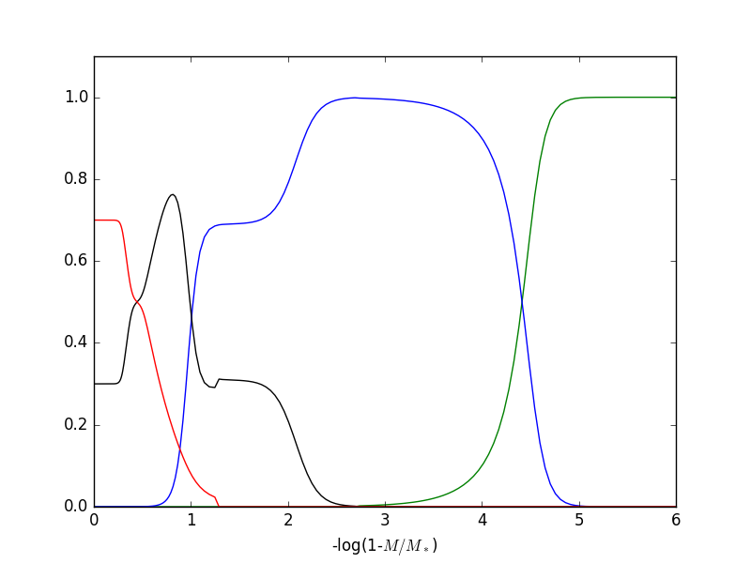

The problem: In our definition of the oxygen profile in inputprof, we allowed it to go too far out.

Define points as x y coordinates, x being in Mr/Mstar

0. 0.7

0.5 0.7

0.6 0.5

0.7 0.5

0.9 0.1

0.92 0.02

1.00 0.0

Fix: modify the last few lines of the oxygen profile definition so it doesn't go as far out.

Define points as x y coordinates, x being in Mr/Mstar

0. 0.7

0.5 0.7

0.6 0.5

0.7 0.5

0.8 0.1

0.82 0.02

0.90 0.0

Issue #2: The carbon abundance (black) suddenly drops from 1, causing a sharp feature in the profile. The helium abundance picks up suddenly.

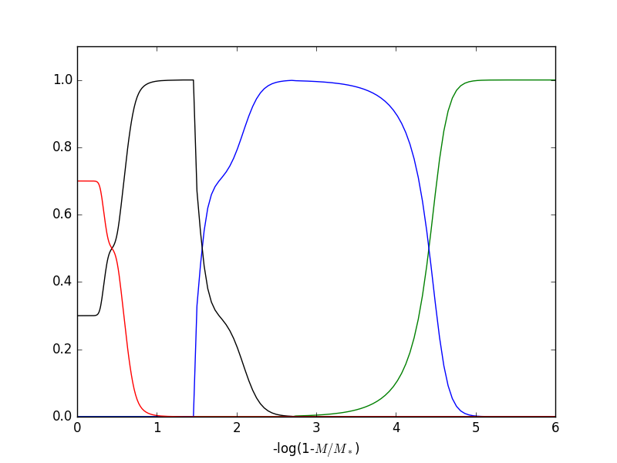

Problem: buffer_inner, defined at the end of inputprof, is not large enough

(last two lines of inputprof)

8.0d-4

1.0d0

Fix: Increase buffer_inner

8.0d-1

1.0d0

Issue #3: The carbon abundance (black) suddenly drops down to zero after turning over, causing a discontinuity in the helium profile as well (blue).

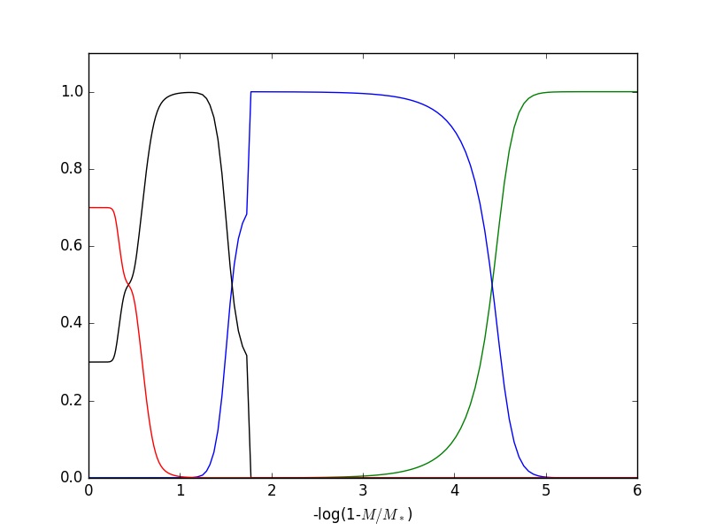Problem: buffer_outer is too big

(last two lines of inputprof)

8.0d-1

2.0d0

Fix: Decrease buffer_outer

8.0d-1

1.0d0

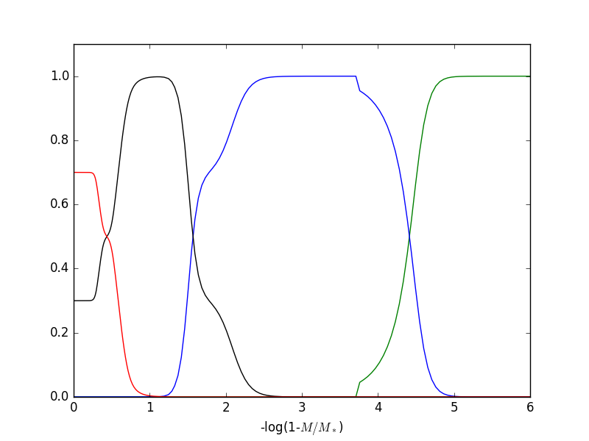Issue #4: The helium abundance (blue) has a weird discontinuity at the helium/hydrogen interface. Hydrogen (green) also picks up in a discontinuous manner.

Problem: buffer_outer is too small

(last two lines of inputprof)

8.0d-1

1.0d-3

Fix: Increase buffer_outer

8.0d-1

1.0d0

Issue #5: Aaaaaaah!

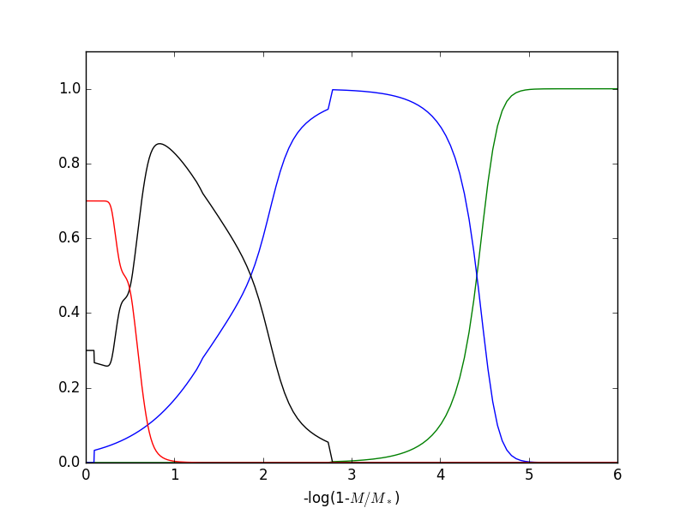

It's a miracle this converged.

Problem: The helium profile at the carbon/helium interface is too gentle in its slope. It does not go down to zero fast enough toward the center, causing all kinds of trouble.

Fix: increase the value of the diffusion coefficient in gridparameters.

11288.0 593.0 160.0 218.0 420.0 69.0 2.0 9.0 1.3

11288.0 593.0 160.0 218.0 420.0 69.0 6.0 9.0 1.3

Issue #6: The helium abundance (blue) grows slowly, then suddenly jumps to 1.

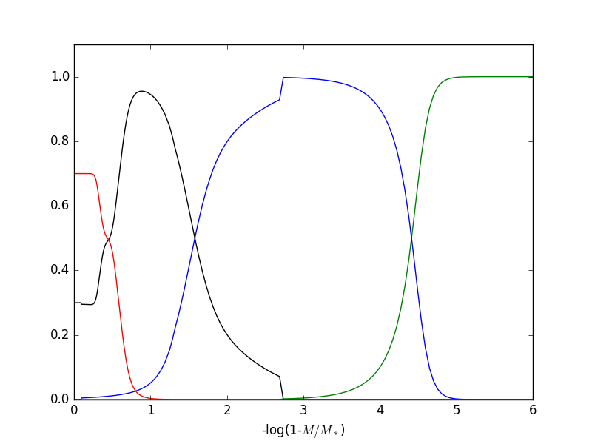

Problem: A diffusion coefficient in gridparameter is too low, causing the helium profile to not get to 1 soon enough.

Fix: Increase the diffusion coefficient in gridparameters

11288.0 593.0 160.0 218.0 420.0 69.0 6.0 2.0 1.3

11288.0 593.0 160.0 218.0 420.0 69.0 6.0 9.0 1.3

Issue #7: Issue #3 (sudden drop of carbon to zero) and Issue #4 (discontinuous tail in the hydrogen profile) both happen at once.

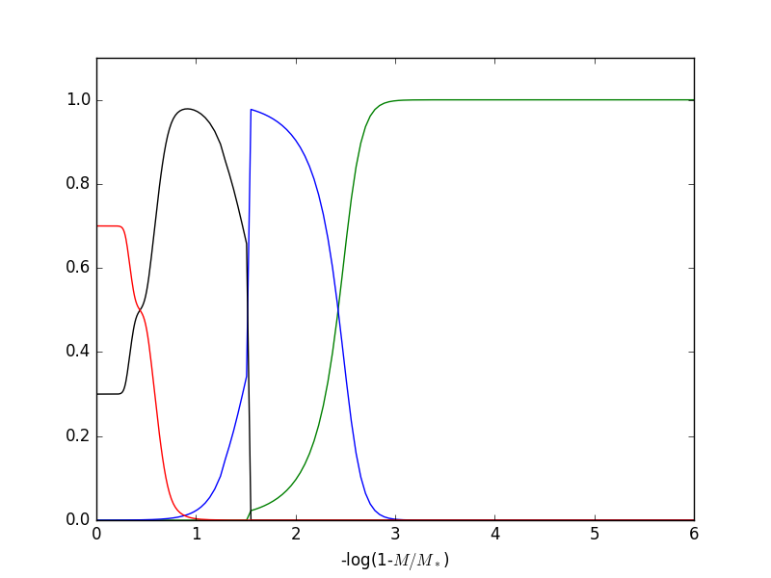

Problem: The helium profile is squeezed too tightly between carbon and hydrogen.

Fix: try increasing the values of the diffusion coefficients (see fix for issue #5 and #6) and adjust buffer_inner and buffer_outer (fix for issue #3 and #4). That may not work, however. You may need to simply give more room for the helium. Choose parameters in gridparameters that are such that they place the base of the hydrogen layer further from the base of the helium layer.

11288.0 593.0 160.0 218.0 220.0 69.0 6.0 12.0 1.3

11288.0 593.0 160.0 218.0 420.0 69.0 6.0 12.0 1.3

A good rule of thumb is to enforce the rule 5th parameter > 3rd parameter + 200 (here 420 > 160 + 200).